**Assignment 1**

1. **Write a program (WAP) to print INEURON using pattern programming logic.**

Solution:

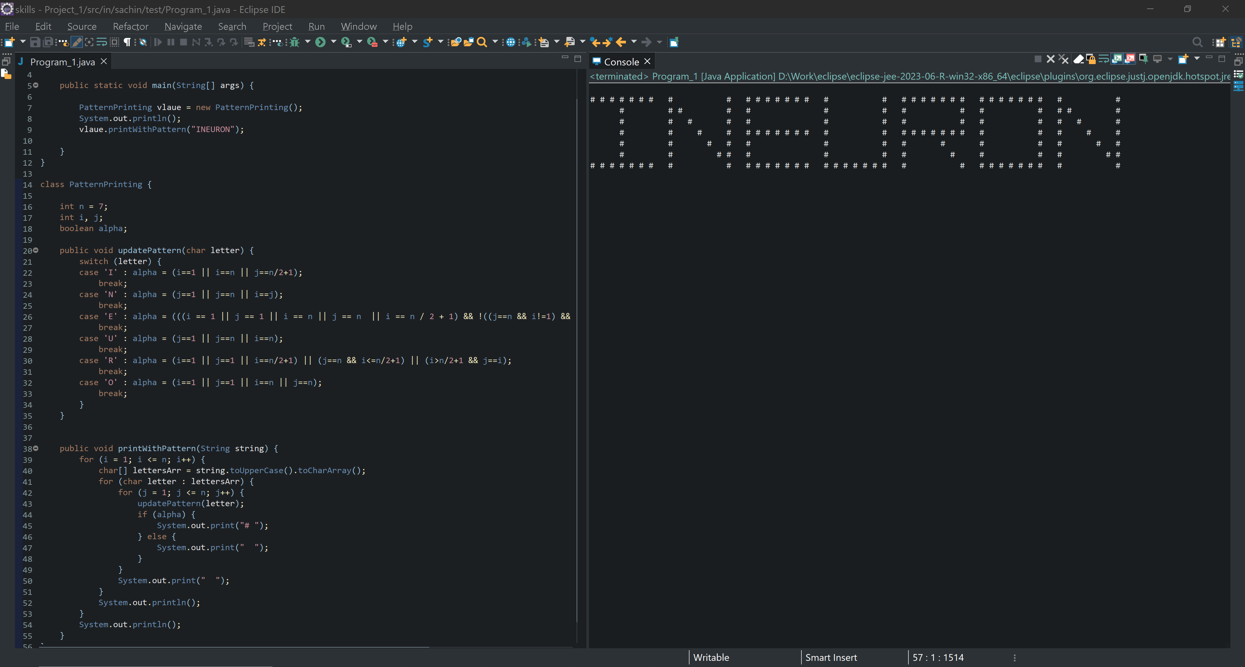

1. **Write a program to print**

1 1 1 1

2 2 2 2

3 3 3 3

4 4 4 4

Solution:

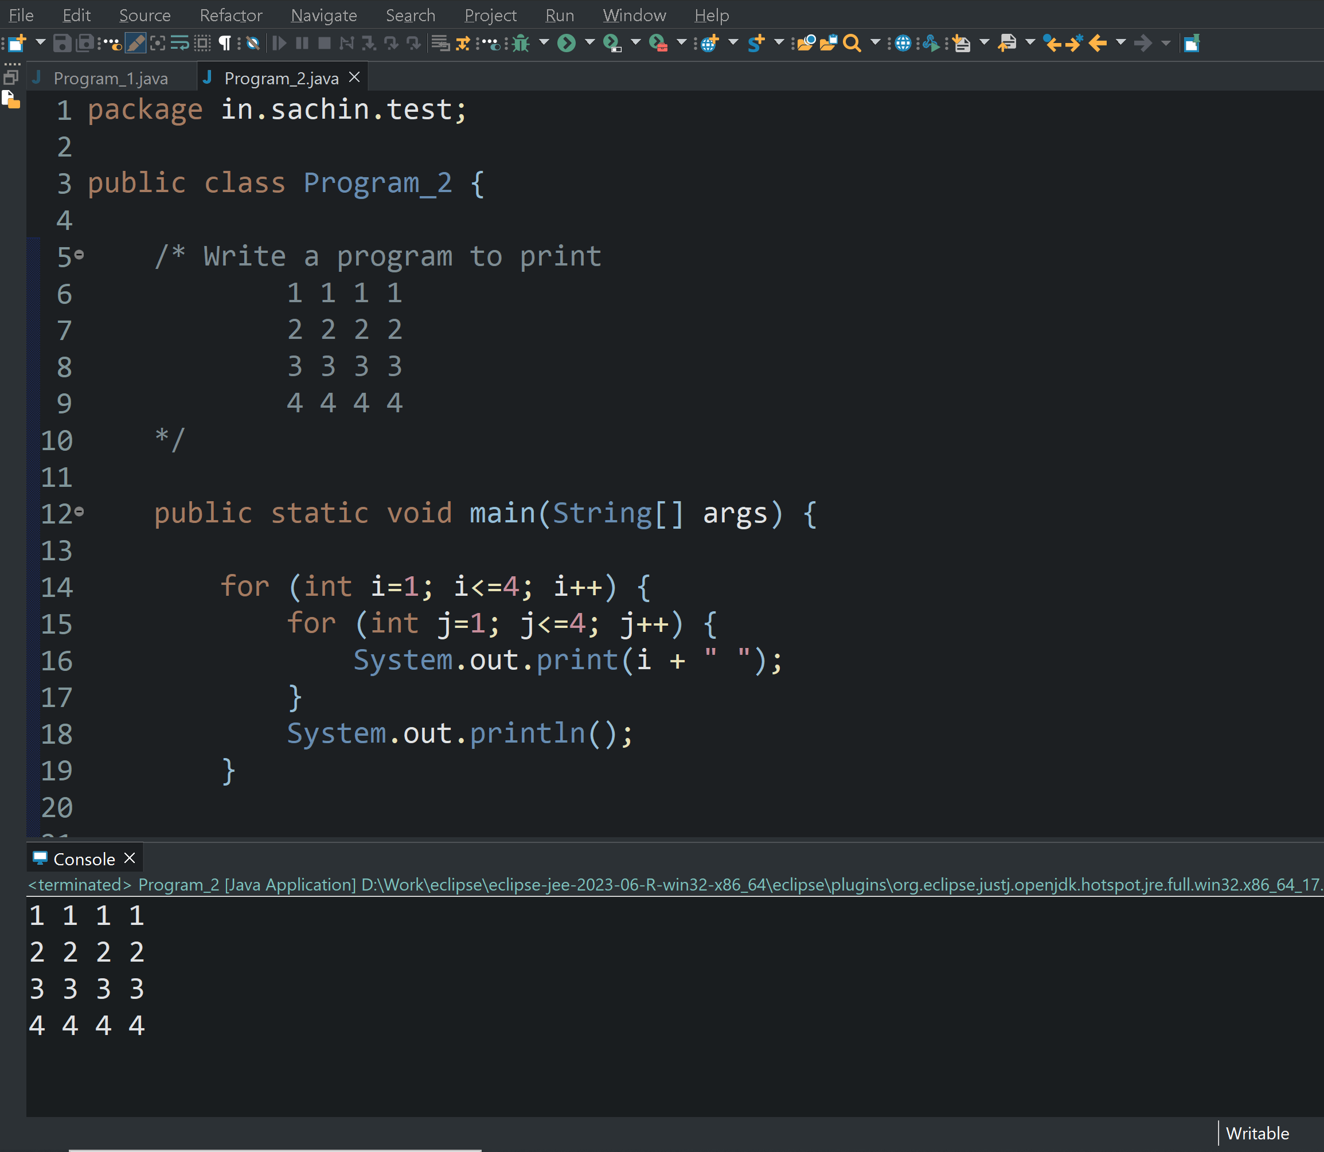

1. **WAP to print.**



Solution:

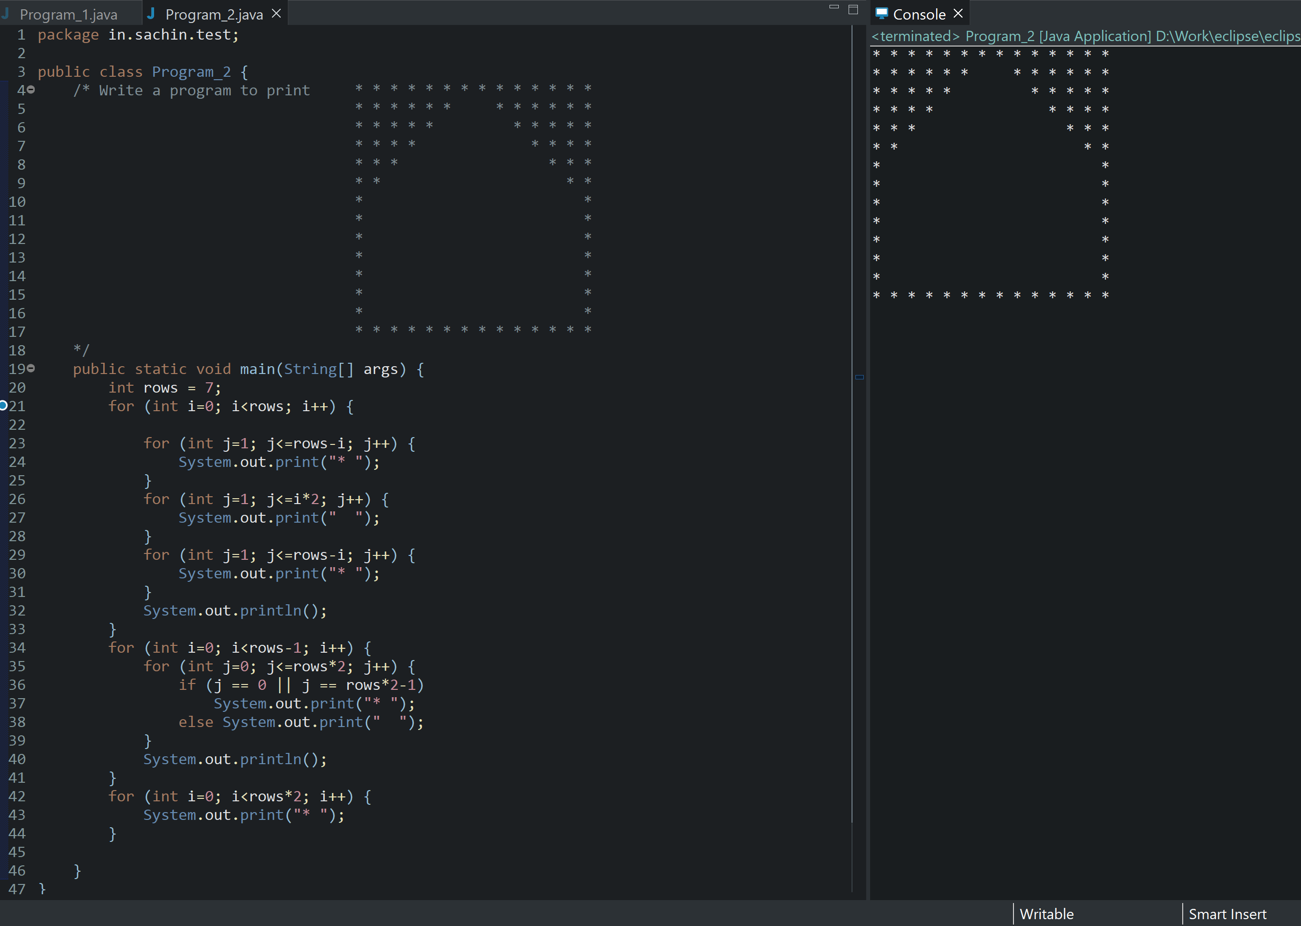

1. **WAP to print**



Solution:

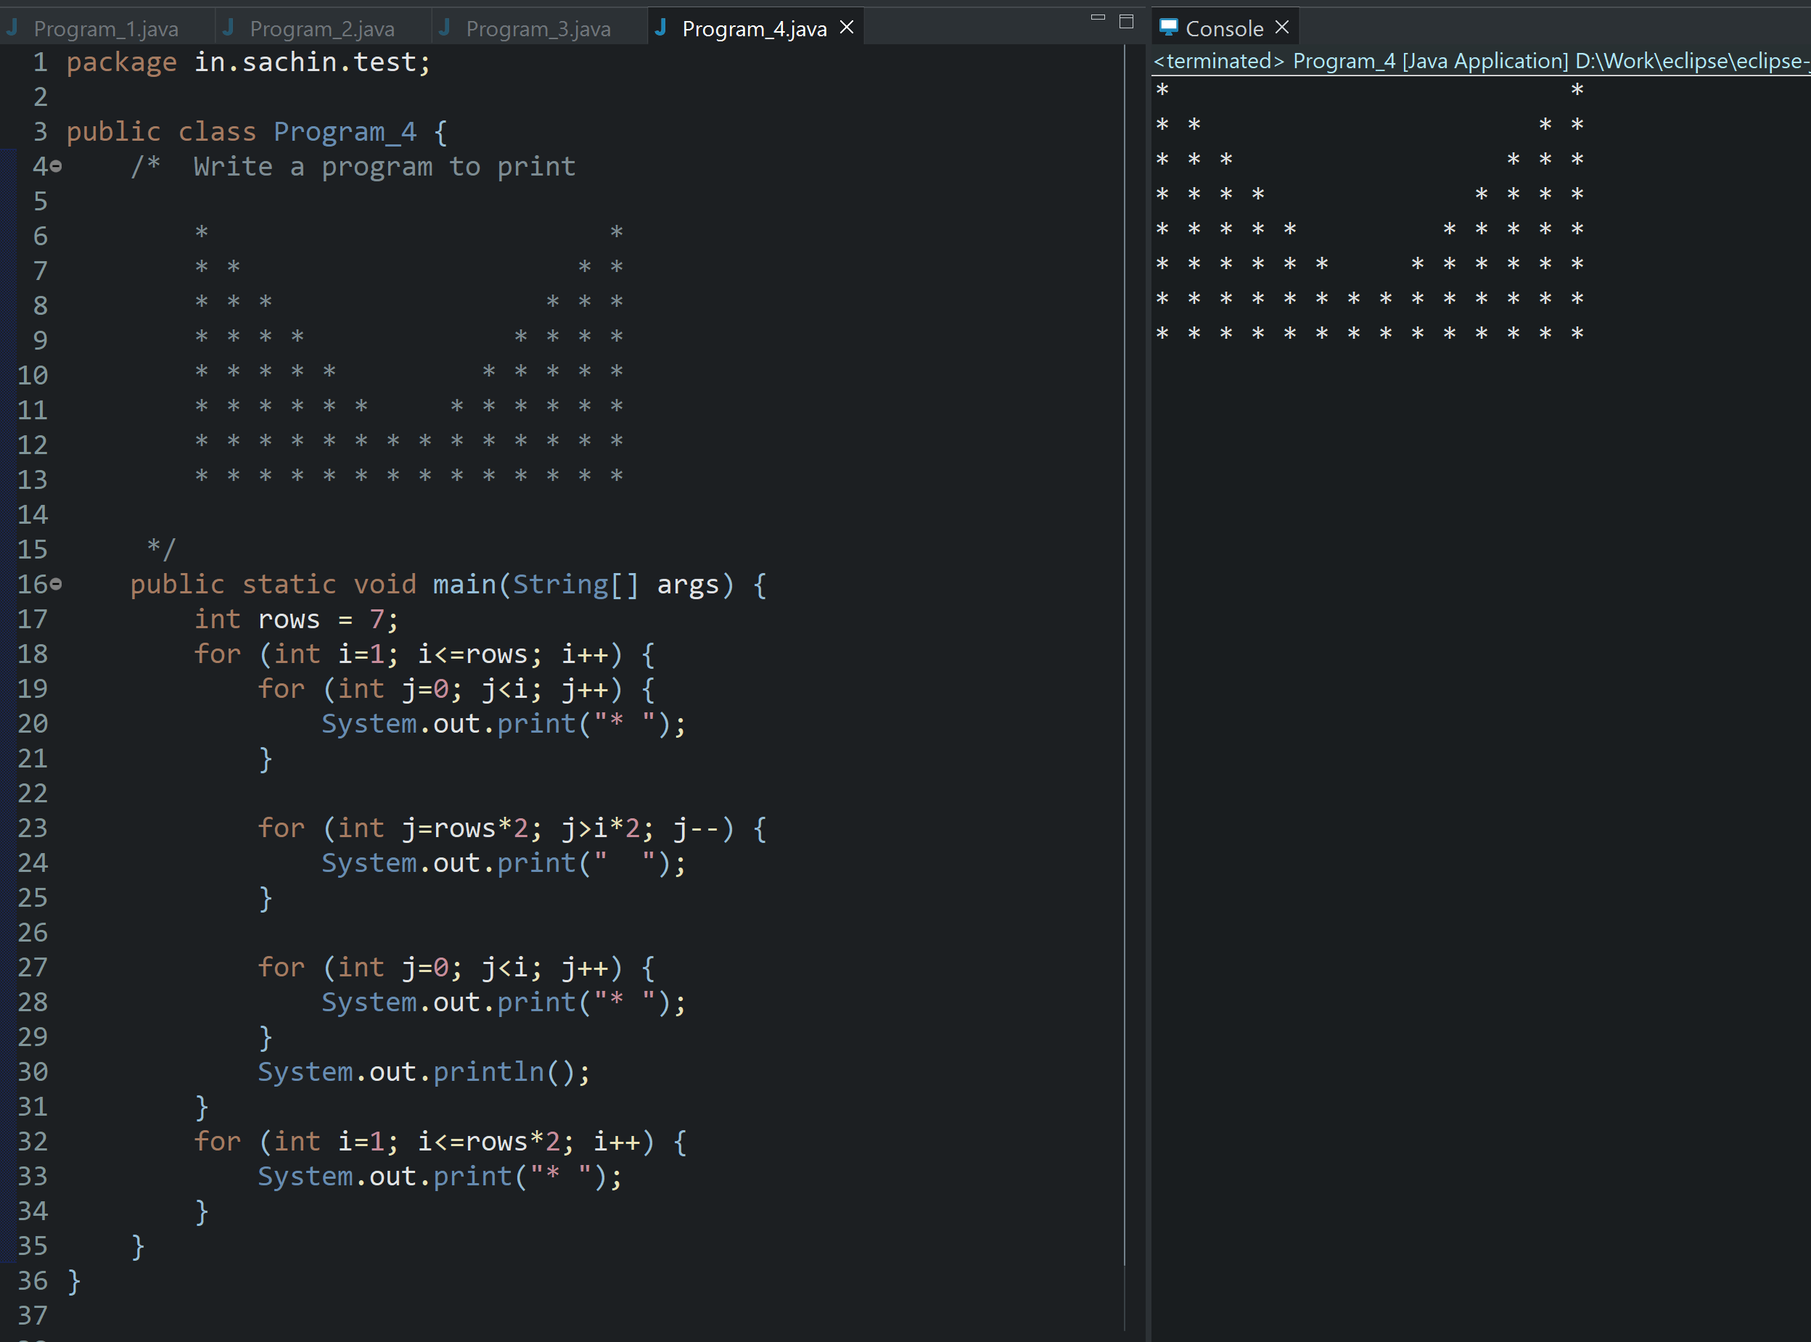

1. **WAP to print**

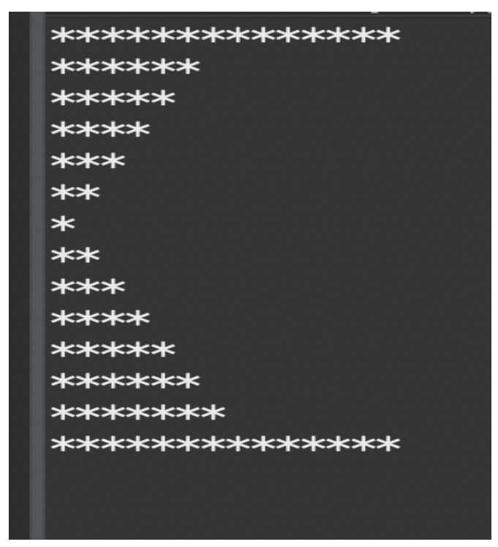

Solution:

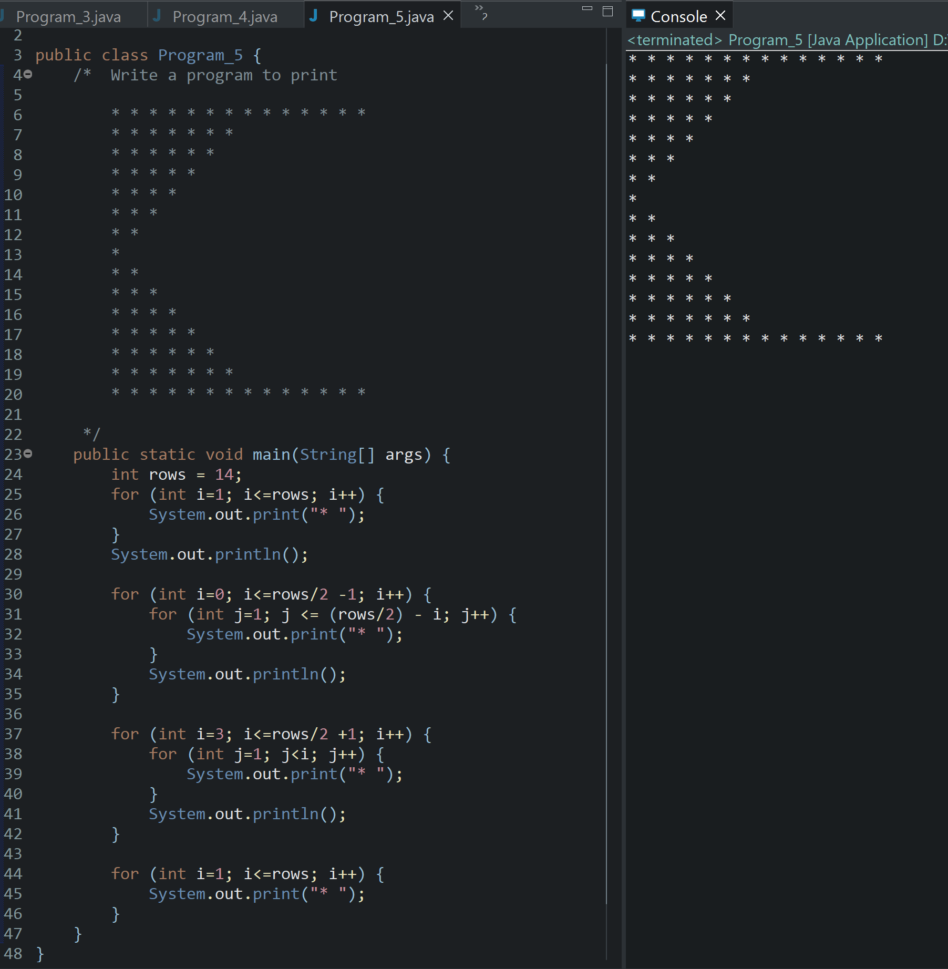

Repository Link: <https://github.com/sachinknsachi/skills.git>